

**IT4020**

**Modern Topics in IT**

**4th Year, 1st Semester**

Assignment 3

**AUGMENTED REALITY**

Submitted to

Sri Lanka Institute of Information Technology

In partial fulfillment of the requirements for the

Bachelor of Science Special Honors Degree in Information Technology

26/03/2020

|  |  |
| --- | --- |
| Student Name | Student ID |
| Rajapakshe D.D.S | IT16234062 |
| U.L.N.P. Uswatte | IT17029278 |
| Kudawithana K.N.B | IT17255820 |
| Nishshanka N.A.B.D | IT17043656 |

[Repository Link](https://github.com/DilrukshiRajapakshe/AR-ass3)

1. **Members Contribution**
2. Rajapakshe D.D.S

* Create individual marker called “pattern-apple.patt”
* Render different artifact on the screen.

Artifact name: “Neck Amphora (515-510 BC)”

* Display the Artifact name and the member’s name in the augmented reality environment.

1. Kudawithana K.N.B

* Create individual marker called “pattern-nb.patt”
* Render different artifact on the screen.

Artifact name: “Venus, a Shetland fourareen”

* Display the Artifact name and the member’s name in the augmented reality environment.
* Render all objects in one single view

1. Nishshanka N.A.B.D

* Create individual marker called “pattern-download.patt”
* Render different artifact on the screen.

Artifact name: “Triceratops Skull Fossil”

* Display the Artifact name and the member’s name in the augmented reality environment.

1. U.L.N.P. Uswatte

* Create individual marker called “pattern-logo.patt”
* Render different artifact on the screen.

Artifact name: “AmmoniteFossil”

* Display the Artifact name and the member’s name in the augmented reality environment.

1. **Screen Shots of all individual applications and the final application**
2. Rajapakshe D.D.S

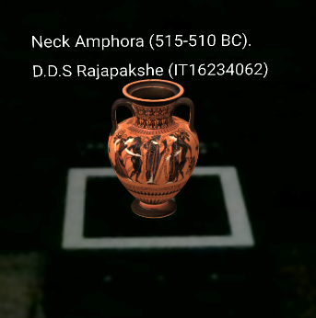

1. Kudawithana K.N.B

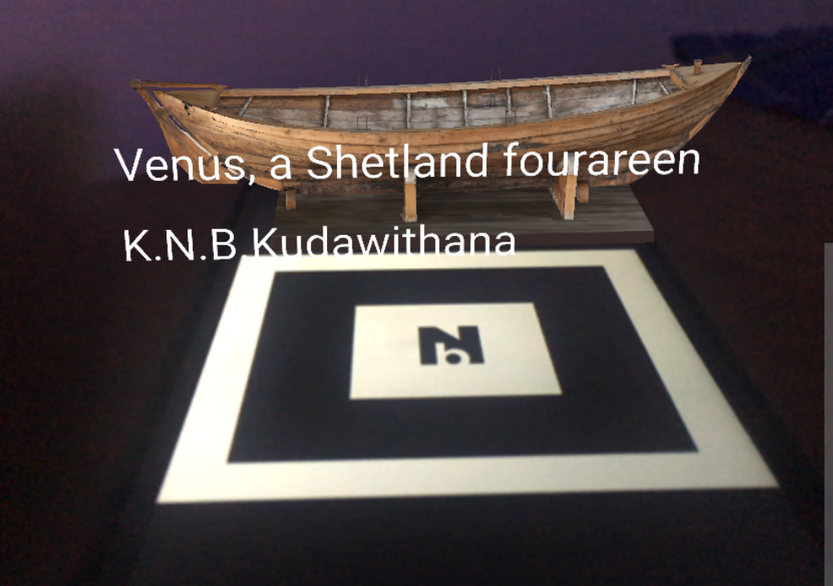

1. Nishshanka N.A.B.D

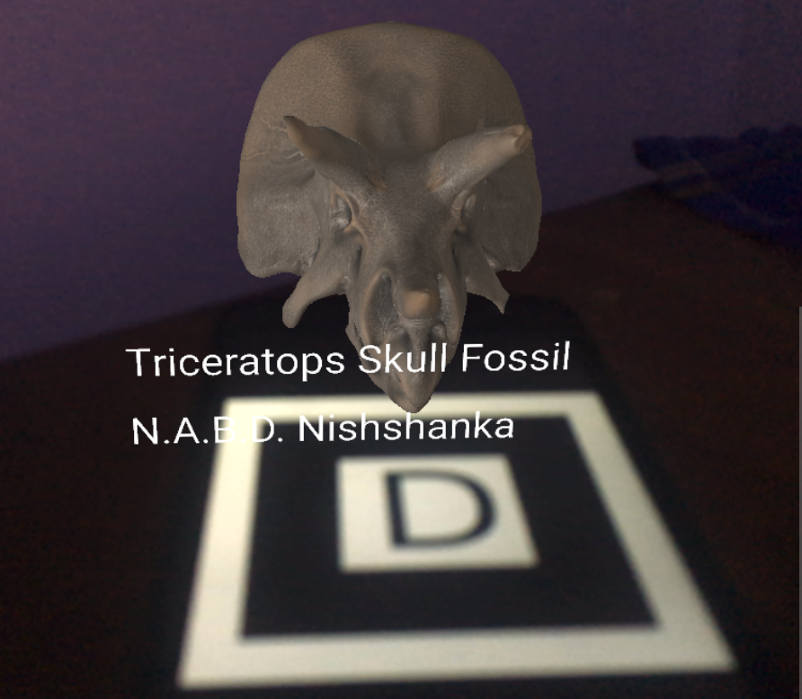

1. U.L.N.P. Uswatte

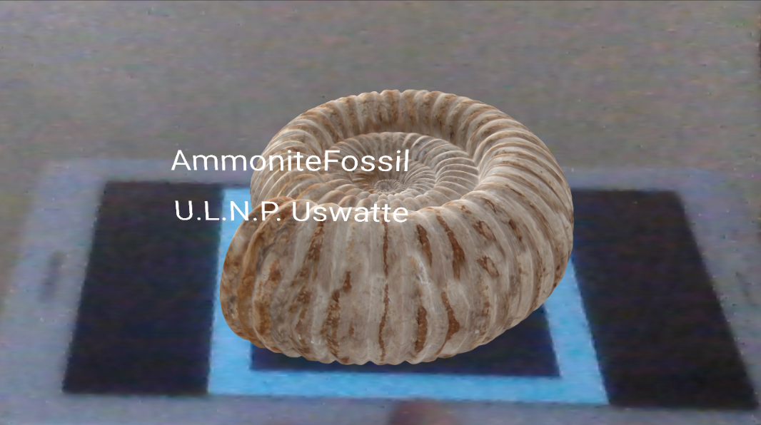

1. Final Application

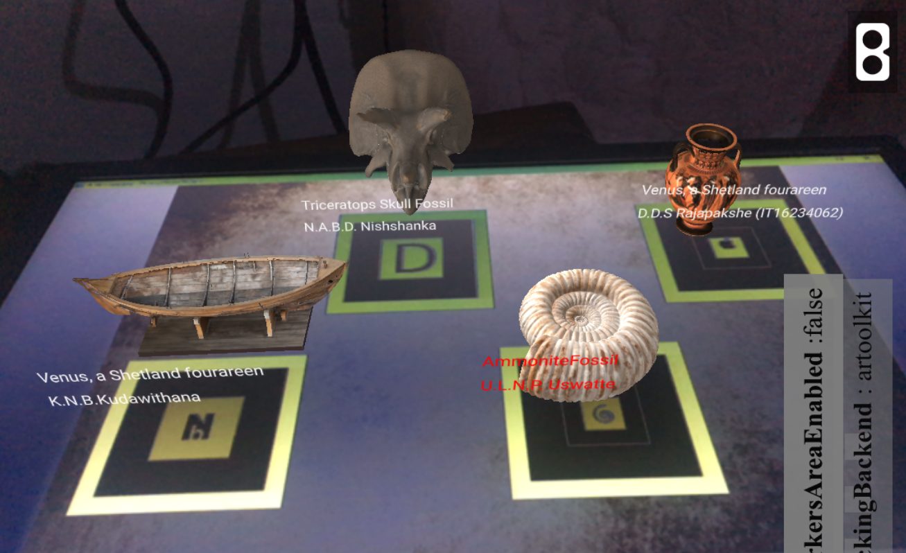

1. **Codes of individual applications and the final application**
2. Rajapakshe D.D.S

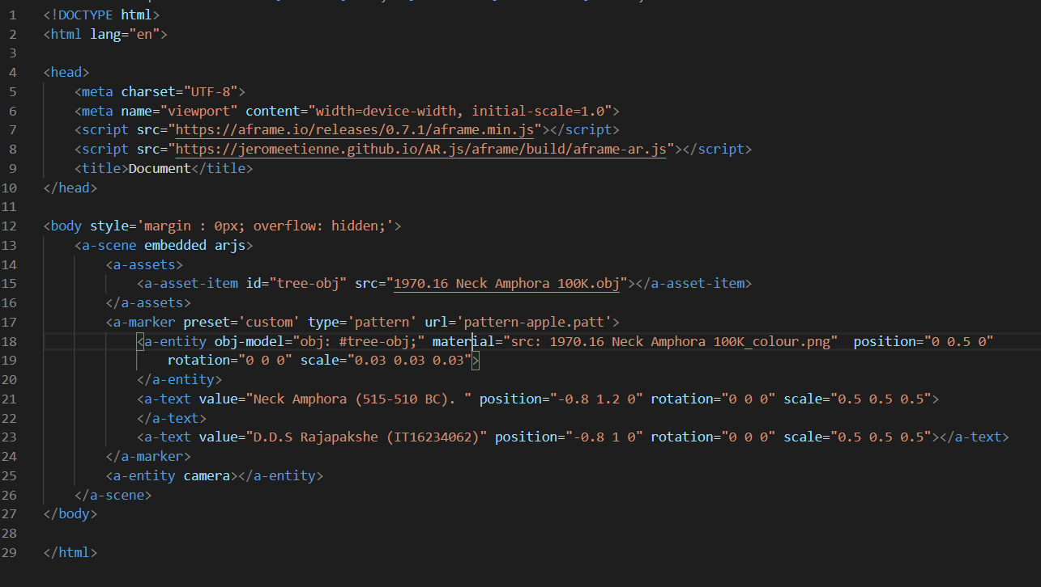

1. Kudawithana K.N.B

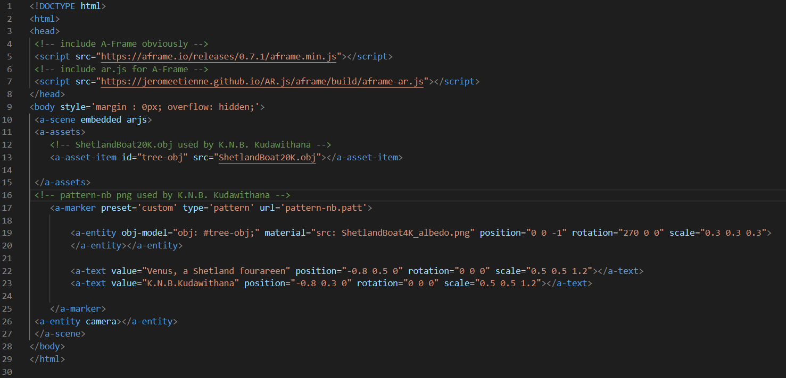

1. Nishshanka N.A.B.D

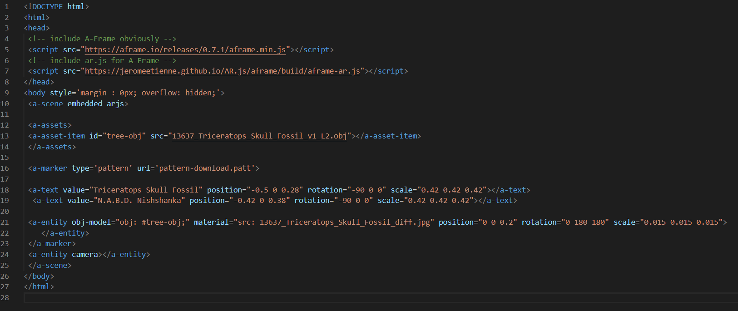

1. U.L.N.P. Uswatte

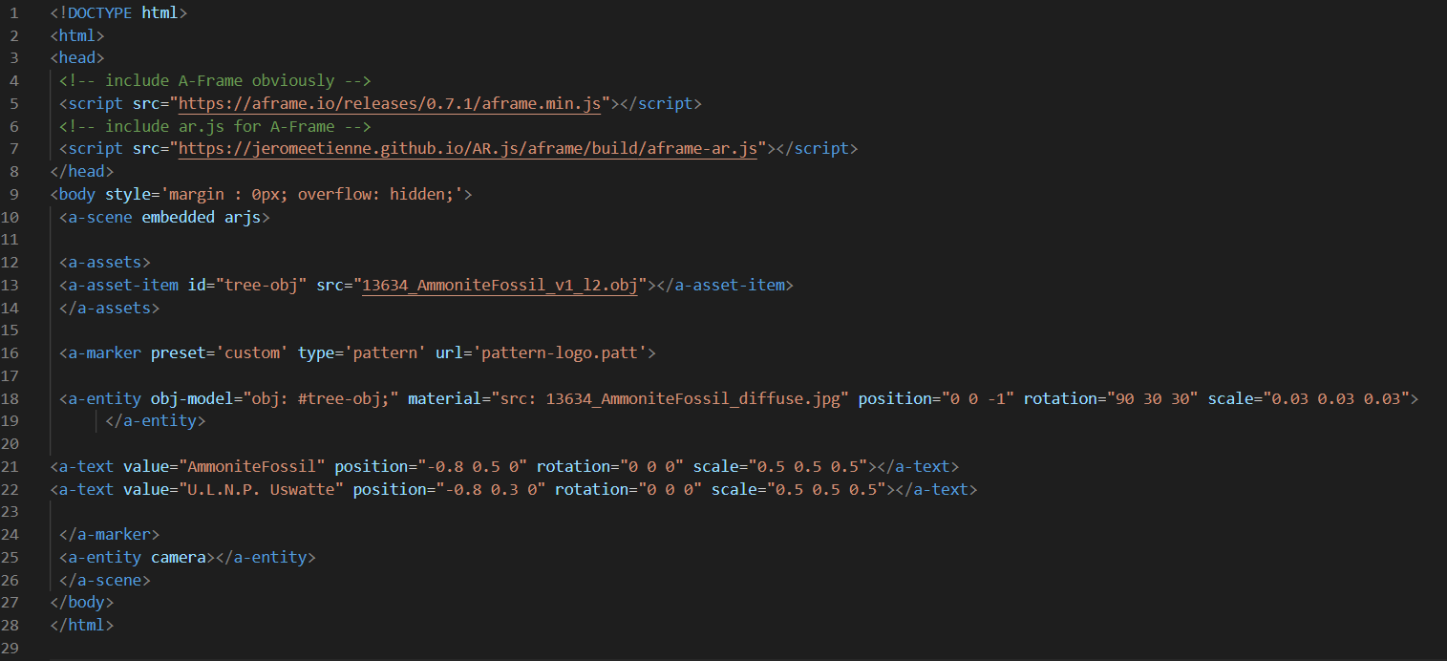

1. Final Application

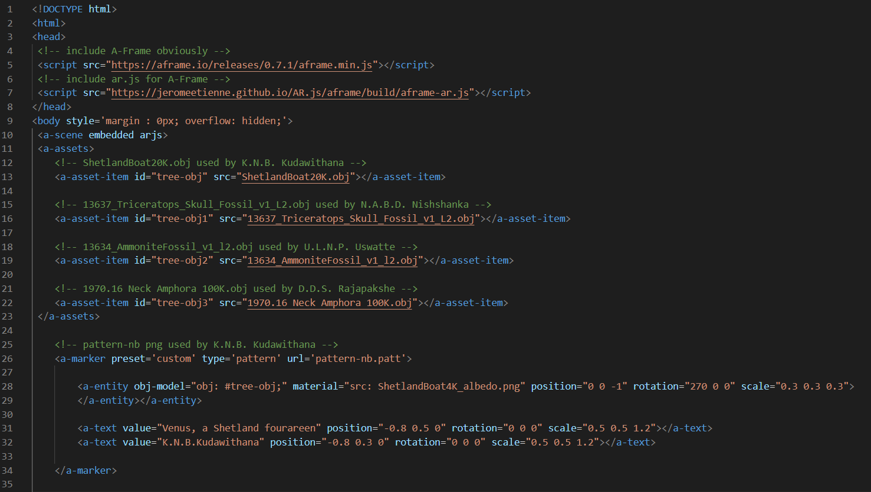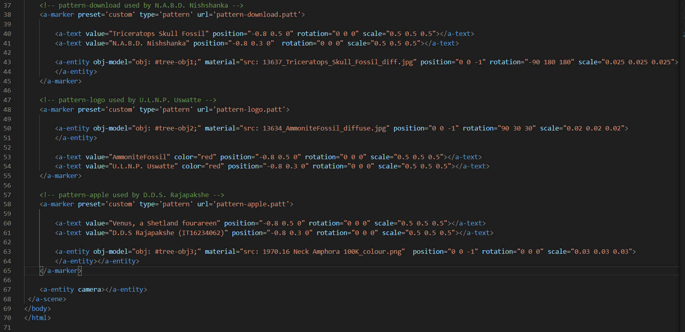

1. **Make a small writeup about a real-life problem where you can apply AR technology to solve it. Discuss within the group to identify it?**

**Abstract:**

This project is an android AR application for the students, teachers, instructors and lecturers in the field of Bio Science and Botany in schools and in higher educational institutions. Here in the application a relevant part of a plant is been captured and a specific information description is given to the particular user. This will enhance the biological knowledge of the relevant groups who uses this application. This brings up the level of the field of science to higher position with the advanced technology. The application will be mostly used by the urban areas as it mostly based with the usage of modern technology. With this the way of studying bio science will be convenient and learners will feel comfortable to learn.

We have decided to use android with Augmented Reality in forming this application. This will be an excitement to the outside world and they will gain a new handful of experiences by using this application.

* When capturing, at first the specific details of the plant is displayed to the user.
* Then the relevant group of which the plant belongs to such as Angiosperms and Gymnosperms will be shown.
* The main parts of a plant such as the leaf, root, trunk, and the flower can be captured by the user. The following points are accordingly shown while capturing the particular part.

1. If the part is the leaf,
   * Horizontal structure of a leaf can be viewed. Also, the structure of the veins of a leaf can be shown.
   * An analyzed description of the leaf is illustrated.
2. If the part is a flower,

* The horizontal structure version is presented.
* An analyzed description is demonstrated to the user.

1. If the part is a trunk,

* Vertical and horizontal structural versions are being presented.
* A biological analyze is given of the trunk. The five main parts of the trunk such as . the bark, inner bark, cambium, sapwood and heartwood can be studied with the . . capturing.

1. If the part is a root,

* Structure of the root is displayed.
* An analysis of the root of the specific plant is demonstrated.

According to the two groups of plants such as the angiosperms and the gymnosperms the roots are also classified with relevant to them. The Angiosperms plants shows fibrous roots and Gymnosperms shows tap roots. And in common an analyze of the roots are presented to the user.

**Objectives:**

* This application will mainly be helpful to the advanced level students of the schools who are studying in the Bio Science stream.
* For the students at school this is very convenient as when students learn through visual aids they find learning more comfortable. In this application videos are given to the students in presenting the details of the plant. So these videos are more practical to the students at school.
* From the point of the students self-studying can be promoted with the using of this application.
* Students will be motivated and will try to find more information about more plants. This will largely increase the biological intellectual proficiency of the students in the schools.
* Teachers at schools will find it more relaxed to teach bio science using this application. Also the knowledge of the teachers will be enhanced with this application.
* Increases the proficiency of the lectures in the field of botany. Lecturers at higher educational institutes will also find it convenient to teach botany to the students.

**Functions:**

* Create a AR Model:

Have to create a model of the relevant part of the tree (Leaf, Roots, Trunk & Flower).

By creating this model, we can view/ generate the details for the captured part of the tree.

* Identify the parts of the tree:

When we capture the part of the tree it should be identify the relevant part & analyze the details of the part.

* Identify the Tree:

From this app it should be identify the tree and its group (whether it is Angiosperms or Gymnosperms). There will be shown the Scientific name of the tree.

* Create a VR Model:

By creating a VR model for the tree/ tree parts user can see its natural view using VR Glasses.